## **What is chatbot architecture**

First you have the front-end, where the user interacts with the bot. The responses get processed by the NLP Engine which also generates the appropriate response.

### **NLP Engine**

NLP Engine is the core component that interprets what users say at any given time and converts the language to structured inputs that system can further process. Since the chatbot is domain specific, it must support so many features. [NLP engine](https://blog.vsoftconsulting.com/blog/introduction-to-natural-language-processing) contains advanced machine learning algorithms to identify the user’s intent and further matches them to the list of available intents the bot supports.

* **Intent Classifier**: Intent classifier takes user’s input identifies its meaning and relates back to one of the intents that the chatbot supports.
* **Entity Extractor**: Entity extractor is what extracts key information from the user’s query.

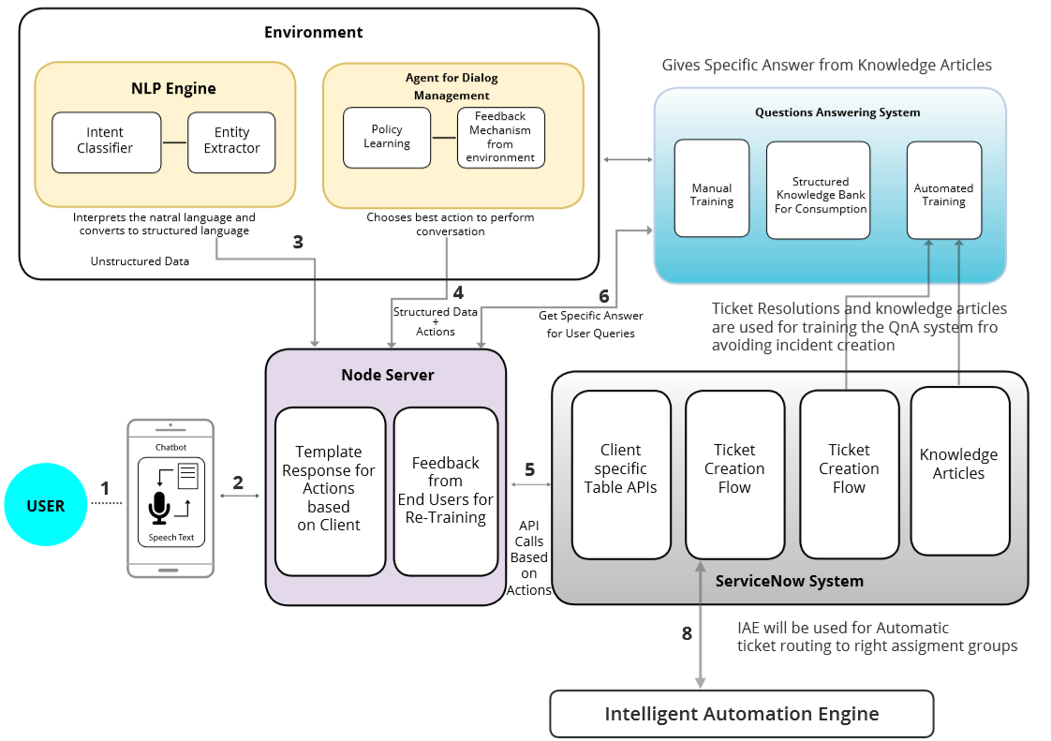

## **What should you consider while developing your chatbot’s architecture?**

Before building your chatbot, remember your audience. The following factors must be considered to ensure usability and a seamless customer experience:

* User-friendliness
* Speed
* Analytics and feedback provision

Source: <https://blog.vsoftconsulting.com/blog/understanding-the-architecture-of-conversational-chatbot>

https://www.engati.com/glossary/chatbot-architecture#toc-what-are-the-components-of-a-chatbot-